Assignment No.6

# Problem Statement:

Implement Bully and Ring algorithm for leader election.

# Code:

1. **Ring**

import java.util.Scanner; public class Ring {

public static void main(String[] args) {

// TODO Auto-generated method stub int temp, i, j;

char str[] = new char[10]; Rr proc[] = new Rr[10];

// object initialisation

for (i = 0; i < proc.length; i++) proc[i] = new Rr();

// scanner used for getting input from console

Scanner in = new Scanner(System.in); System.out.println("Enter the number of process : "); int num = in.nextInt();

// getting input from users

for (i = 0; i < num; i++) { proc[i].index = i;

System.out.println("Enter the id of process : "); proc[i].id = in.nextInt();

proc[i].state = "active"; proc[i].f = 0;

}

// sorting the processes from on the basis of id

for (i = 0; i < num - 1; i++) {

for (j = 0; j < num - 1; j++) {

if (proc[j].id > proc[j + 1].id) { temp = proc[j].id; proc[j].id = proc[j + 1].id; proc[j + 1].id = temp;

}

}

}

for (i = 0; i < num; i++) {

System.out.print(" [" + i + "]" + " " + proc[i].id);

}

int init;

ordinator");

int ch; int temp1; int temp2; int ch1;

int arr[] = new int[10]; proc[num - 1].state = "inactive";

System.out.println("\n process " + proc[num - 1].id + "select as co-

while (true) {

System.out.println("\n 1.election 2.quit "); ch = in.nextInt();

for (i = 0; i < num; i++) { proc[i].f = 0;

}

switch (ch) { case 1:

initialsied election : ");

proc[temp1].f == 0) {

System.out.println("\n Enter the Process number who

init = in.nextInt(); temp2 = init;

temp1 = init + 1; i = 0;

while (temp2 != temp1) {

if ("active".equals(proc[temp1].state) &&

System.out.println("\nProcess " +

proc[init].id + " send message to " + proc[temp1].id);

proc[temp1].f = 1; init = temp1;

arr[i] = proc[temp1].id; i++;

}

if (temp1 == num) {

temp1 = 0;

} else {

temp1++;

}

}

System.out.println("\nProcess " + proc[init].id + " send message to " + proc[temp1].id);

arr[i] = proc[temp1].id; i++;

int max = -1;

// finding maximum for co-ordinator selection

for (j = 0; j < i; j++) { if (max < arr[j]) {

max = arr[j];

}

}

// co-ordinator is found then printing on console

System.out.println("\n process " + max + "select as co-

ordinator");

for (i = 0; i < num; i++) {

if (proc[i].id == max) {

proc[i].state = "inactive";

case 2:

}

}

break;

System.out.println("Program terminated ..."); return ;

default:

System.out.println("\n invalid response \n"); break;

}

}

}

}

class Rr {

public int index; // to store the index of process public int id; // to store id/name of process public int f;

String state; // indiactes whether active or inactive state of node

}

# Bully

import java.io.InputStream; import java.io.PrintStream; import java.util.Scanner;

public class Bully {

static boolean[] state = new boolean[5]; int coordinator;

public static void up(int up) { if (state[up - 1]) {

System.out.println("process" + up + "is already up");

} else {

int i;

Bully.state[up - 1] = true; System.out.println("process " + up + "held election"); for (i = up; i < 5; ++i) {

System.out.println("election message sent from process" + up + "to process" + (i + 1));

}

for (i = up + 1; i <= 5; ++i) { if (!state[i - 1]) continue;

System.out.println("alive message send from process" + i + "to

process" + up);

}

}

}

break;

public static void down(int down) { if (!state[down - 1]) {

System.out.println("process " + down + "is already dowm.");

} else {

Bully.state[down - 1] = false;

}

}

public static void mess(int mess) { if (state[mess - 1]) {

if (state[4]) { System.out.println("0K");

} else if (!state[4]) { int i;

System.out.println("process" + mess + "election"); for (i = mess; i < 5; ++i) {

System.out.println("election send from process" + mess + "to process " + (i + 1));

}

for (i = 5; i >= mess; --i) { if (!state[i - 1]) continue;

System.out.println("Coordinator message send from process" + i +

"to all");

}

break;

}

} else {

System.out.println("Prccess" + mess + "is down");

}

}

public static void main(String[] args) { int choice;

Scanner sc = new Scanner(System.in); for (int i = 0; i < 5; ++i) {

Bully.state[i] = true;

}

System.out.println("5 active process are:"); System.out.println("Process up = p1 p2 p3 p4 p5"); System.out.println("Process 5 is coordinator");

do {

System.out.println(" ");

System.out.println("1 up a process."); System.out.println("2.down a process"); System.out.println("3 send a message"); System.out.println("4.Exit");

choice = sc.nextInt(); switch (choice) {

case 1: {

System.out.println("bring proces up"); int up = sc.nextInt();

if (up == 5) {

System.out.println("process 5 is co-ordinator"); Bully.state[4] = true;

break;

}

Bully.up(up); break;

}

case 2: {

System.out.println("bring down any process."); int down = sc.nextInt();

Bully.down(down); break;

}

case 3: {

System.out.println("which process will send message"); int mess = sc.nextInt();

Bully.mess(mess);

}

}

} while (choice != 4);

}

}

# OUTPUT:

1. **Ring**

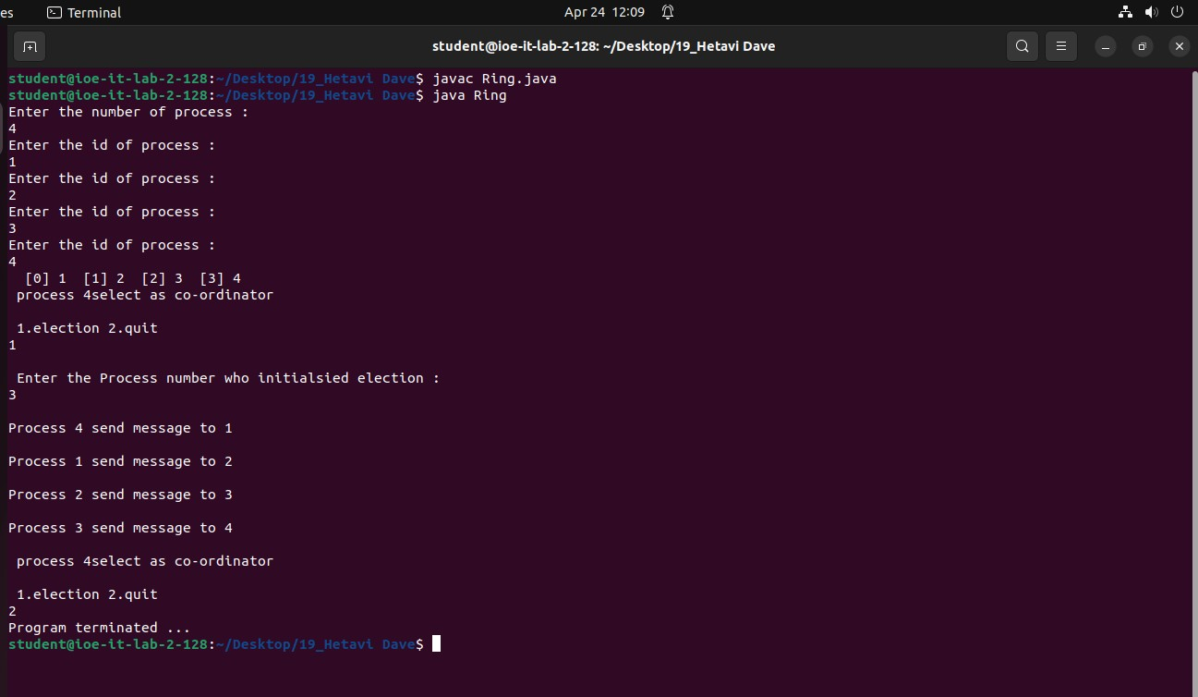

1. **Bully**

